User stories | Process One (Plan Design and Arts) | Time consumption （Week 1 - 2） | priority
1 | Game story definition | 2 days | M
2 | Game logic definition | 1 days | H
3 | Character definition | 1 day | H
4 | Draft and prototype | 2 days | H
5 | Art work of stage | 2 days | M
6 | Art work of character | 2 days | M
7 | Art work of elements | 2 days | L
8 | Art work of background and accessories | 1 day | L
9 | Client communication and Milestone meeting | 1 day

User stories | Process Two (Alpha Version) | Time consumption （Week 3 - 7） | priority
1 | Build title screen | 4 days | H
2 | Flying cloud | 1 day | L
3 | Jumping rabbits | 1day | L
4 | Moving grass | 1 day | L
5 | Play button | 2 days | H
6 | Levels Option screen | 1 day | M
7 | Round 1 selection | 1 day
8 | High score of round 1 | 2 days | H
9 | Main screen | 2 days | H
10 | Load parameter for different level  Number of eagles: 5  Speed of eagles: 450 | 1 day | M
11 | Create eagle | 1 day | H
12 | Eagles fly to rabbits frequently | 1 day | H
13 | Eagles catching rabbit | 2 day | H
14 | Eagles carting rabbit vertically to out of layer | 1 day | H
15 | Carrots could be dragged, ready for shot | 1 day | H
16 | Carrots shotting | 1 day | H
17 | Carrots hit eagle (with explosion effect) | 2 days | H
18 | Carrots does not hit eagle | 2 days | H
19 | Rabbit lay out to grass | 1 day | L
20 | Rabbit caught by eagle on flying | 1 day | H
21 | Rabbit caught by eagle successfully out of layout | 1 day | H
 | Rabbit be saved (reset the rabbit) | 1 day | H
22 | When eagle number reduce to 0 (winner action: again or go next level) | 1 day | M
23 | When carrot number reduce to 0 (loser action: again) | 1 day | M
24 | When rabbit number reduce to 0(loser action: again) | 1 day
25 | Milestone 2 Client meeting | 5 days

User stories | Process Three (Beta Version) | Time consumption（Week 8 - 10） | priority
1 | Test Alpha related functions | 1 day
2 | Test Alpha related functions | 1 day
3 | Test Alpha related functions | 1 day
4 | Test Alpha related functions | 1 day
5 | Test Alpha related functions | 1 day
6 | Test Alpha related functions | 1 day
7 | Back to title | 1 day
8 | Test Alpha related functions | 1 day
9 | Round 2 selection | 1 day
10 | Test Alpha related functions | 1 day
11 | High score of round 2 | 1 day
12 | If locked, in round 2 | 1 day
13 | Test Alpha related functions | 1 day
14 | Particular in level2  Number of eagles: 7  Speed of eagles: 600 | 3 days
15 | Can tweet simultaneously | 2 days
16 | Eagles fly to rabbits randomly  Case number of rabbits on the stage:  4→choose(1,2,3,4)  3→ if 1 gone then choose(2,3,4)  if 2 gone then choose(1,3,4)  if 3 gone then choose(1,2,4)  if 4 gone then choose(1,2,3)  2→ if 1 2 gone then choose(3,4)  if 1 3 gone then choose(2,4)  if 1 4 gone then choose(2,3)  if 2 3 gone then choose(1,4)  if 2 4 gone then choose(1,3)  if 3 4 gone then choose(1,2)  1→choose the last one | 3 days
17 | Test Alpha related functions | 1 day
18 | Test Alpha related functions | 1 day
19 | Test Alpha related functions | 1 day
20 | Test Alpha related functions | 1 day
21 | Optimization of explosion effect:  Add Fade behaviour to explosion effect | 3 days
22 | Test Alpha related functions | 1 day
23 | Test Alpha related functions | 1 day
24 | Test Alpha related functions | 1 day
25 | Test Alpha related functions | 1 day
26 | Test Alpha related functions | 1 day
27 | Test Alpha related functions | 1 day
28 | Test Alpha related functions | 1 day
29 | Test Alpha related functions | 2 days
30 | Next level (set eagle more speedy and increase the number of eagle) | 2 days
31 | High score (The playing time lower than high score, then replace to save)  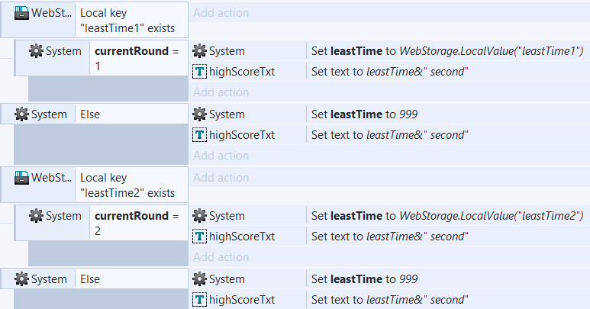 | 3 days
32 | Final documentation (Presentation and Final Audit)

